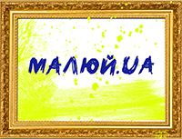
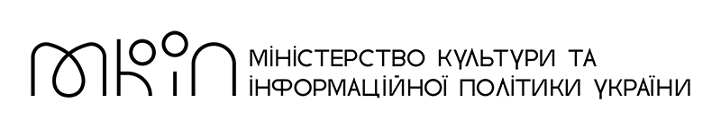
APPLICATION FORM
The application together with a portrait photo of the participant and a photo of up to three works must be sent on e-mail: adrumukraine@gmail.com

Data

Phone
Indicate which messenger you use (Viber, WhatsApp, Telegram)
E-mail
Facebook profile (if you have)

Instagram profile (if you have)

How did you find out about the festival?

All fields are required in English
Data
Name, surname
Age
Country, city / village
Picture 1:
Name, size, materials year of creation
Picture 2:
Name, size, materials year of creation
Picture 3:
Name, size, materials year of creation

