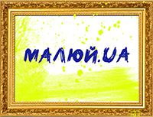
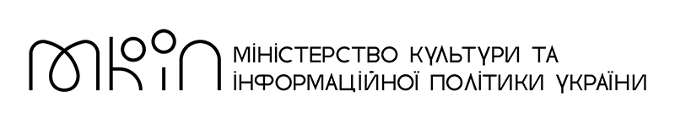
APPLICATION FORM
VI International Art Festival МАЛЮЙ.UA
The application together with a portrait photo of the participant and a photo of up to three works must be sent on e-mail: adrumukraine@gmail.com

Name, surname
Age
Country, city / village
Name, size, materials, year of creation of Picture 1
Name, size, materials, year of creation of Picture 2
Name, size, materials, year of creation of Picture 3
Phone
Indicate which messenger you use (Viber, WhatsApp, Telegram)
E-mail
Facebook profile (if you have)

Instagram profile (if you have)

How did you find out about the festival?

