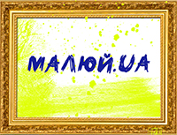
APPLICATION FORM
XVIII International Art Festival МАЛЮЙ.UA
The application together with a portrait photo of the participant and a photo of up to five works must be sent on e-mail: adrumukraine@gmail.com

Name, surname
Age
Country, city / village
Picture 1
Name, size, materials, year of creation
Picture 2
Name, size, materials, year of creation
Picture 3
Name, size, materials, year of creation
Picture 4
Name, size, materials, year of creation
Picture 5
Name, size, materials, year of creation
Phone
Indicate which messenger you use (Viber, WhatsApp, Telegram)
Facebook profile (if you have)

Instagram profile (if you have)

How did you find out about the festival?

